Microsoft Agent Framework (MAF) and Microsoft Foundry Agent Service
Technical Documentation-week 6 day 1 and 2 (10 November)

Executive Summary
Microsoft Agent Framework is Microsoft's open framework for building AI agents and multi-agent workflows. Foundry Agent Service is the managed Azure service used to deploy, operate, secure and scale those agents.

What is Microsoft Agent Framework (MAF)?
MAF is an open, multi-language framework supporting Python, .NET and Go. It provides agents, workflows, memory, tools, orchestration, observability and integrations. Use it when you want flexibility, custom orchestration and provider choice.

Core Terminologies
Agent: software entity using LLMs and tools. Workflow: orchestrated sequence of actions. MCP: Model Context Protocol. RAG: Retrieval Augmented Generation. Agent Harness: planning and long-running execution layer. Memory: short-term and long-term context.

Architecture Deep Dive
Layers include models, memory, tools, workflows, agents and observability. Developers may employ sequential, parallel, handoff and human-in-the-loop orchestration patterns.

What is Microsoft Foundry Agent Service?
A fully managed platform within Microsoft Foundry/Azure AI Foundry that hosts, scales and governs AI agents. It provides managed runtime, monitoring, identity, security, toolboxes, model access and enterprise operations.

MAF vs Foundry Agent Service
MAF is for building. Foundry Agent Service is for running and managing in production. Many organizations use both together.

Enterprise Capabilities
Microsoft Entra ID integration, RBAC, monitoring, Application Insights, Content Safety, networking controls, governance and observability.

Implementation Journey
Prototype with MAF, test workflows, deploy to Foundry Agent Service, observe telemetry, optimize prompts and tools, then scale.

Advanced Topics
Multi-agent systems, durable execution, checkpointing, RAG pipelines, agent memory, governance, evaluation frameworks, and human oversight.

Best Practices
Start simple, add tools incrementally, implement observability early, measure latency/token usage, apply security guardrails and maintain human approval for critical actions.

MAF Architecture Infographic
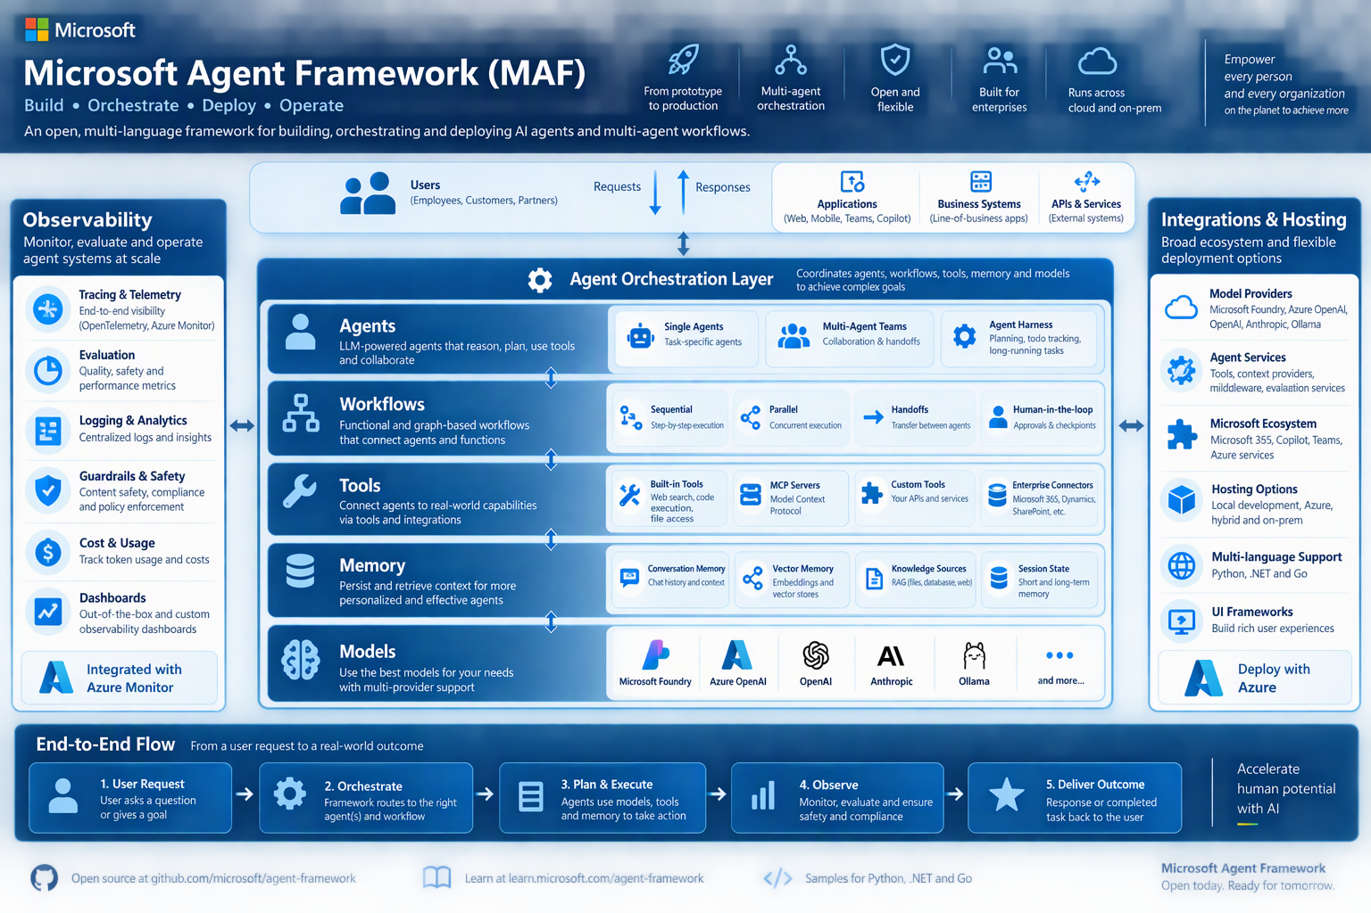
AF vs Foundry Comparison
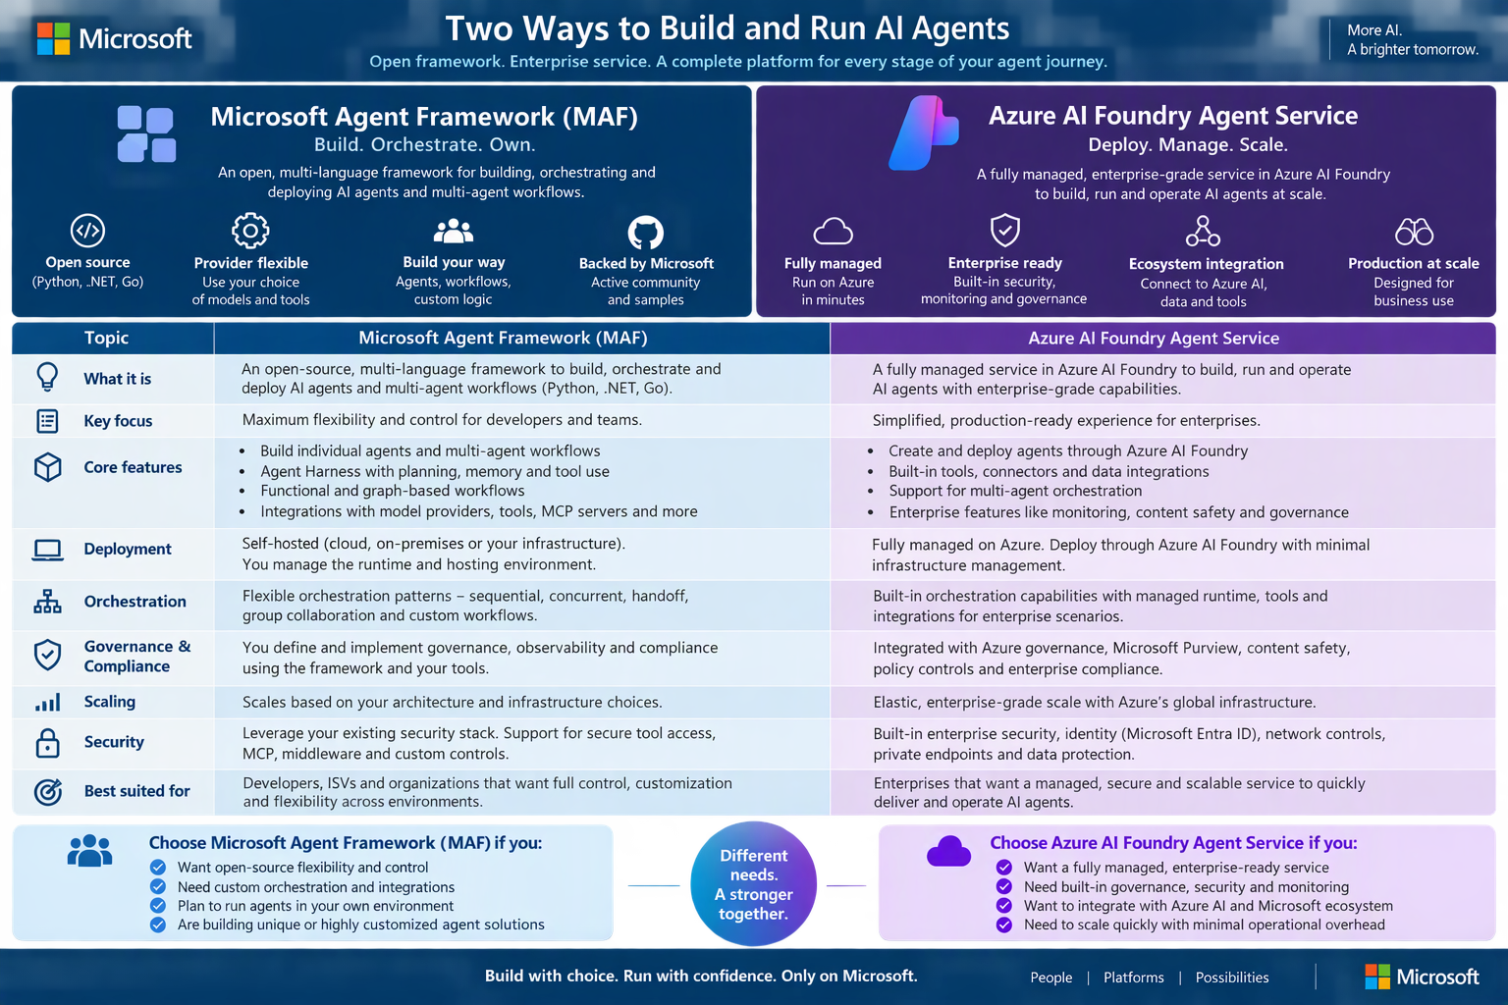
AI Agent Lifecycle


